Pin announcement

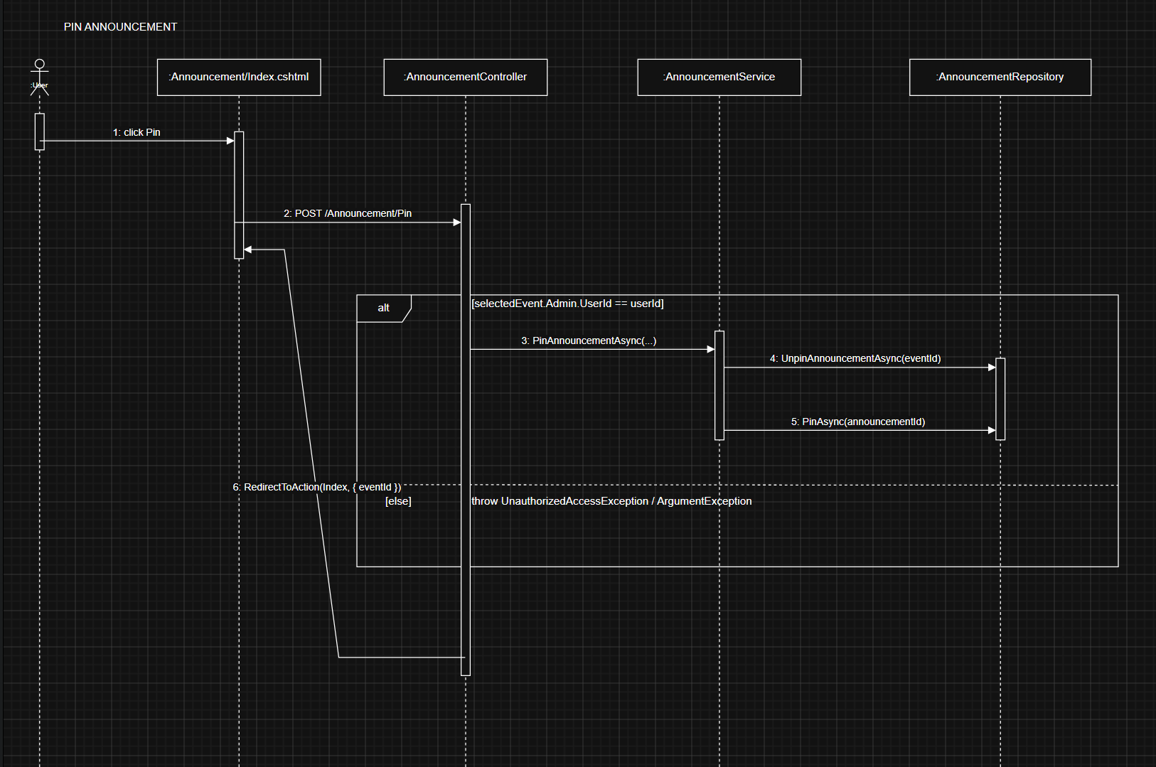
Code:

Controller:
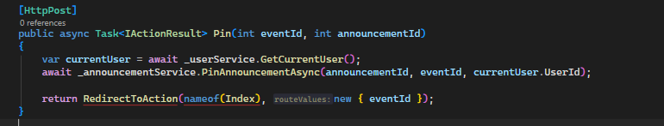

Service:
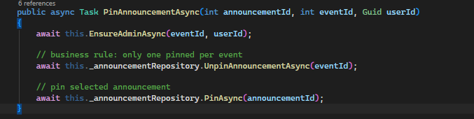
Repository:
